# Portal Modifications – Extend Access to Ecommerce Transactions (App)

## Apr 11th 2019

* Extended Access to Ecommerce Transactions is an app available to :
  + Managers **with Extended Access**
  + Administrators
* It is designed to extend access to **Individual** purchases – NOT Group purchases;
* You enter the Learner Id (User Id) of the **Ecommerce Purchaser;**
* Specify the Program Id and the number of days you wish to extend access (typically 30 or 60);
* Note: a negative number will effectively force the transaction to be expired – the best value to use for this is **-1** as this will reset the “Expires Day” to **yesterday**.
* This app is also available as a web service; best issued to customers that have single/individual purchases.

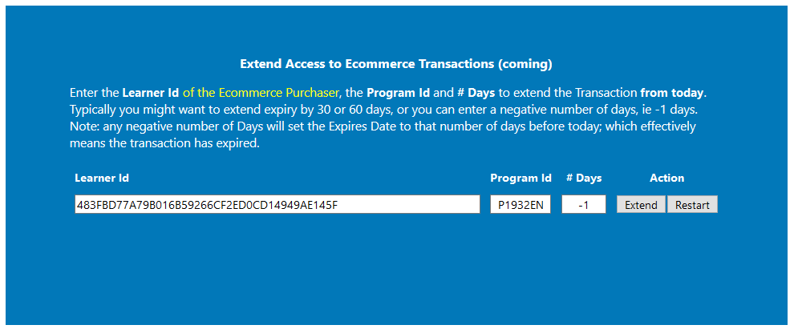

* Now, once saved, exit then return and review this learner; these new values will be rendered in a more fluid manner:

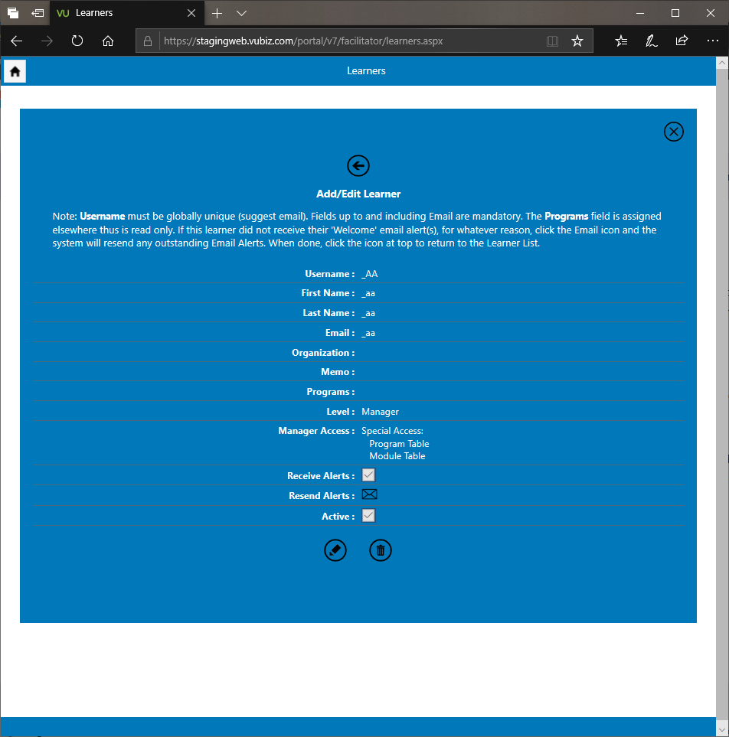

* To test, if you log out as big admin then log in as a manager and click on the Manager Services tile, you will see two features not normally there: “Modules” and “Programs”, since we’ve extended these rights to this person. (Note: the Modules and Programs apps are not yet completed – these tiles are placeholders.
* If you wish to add a new manager, remember to log out and sign back in as big admin.